Registration Form of the Japan Education Forum XII

Date: Thursday, February 5, 2015 （1day）
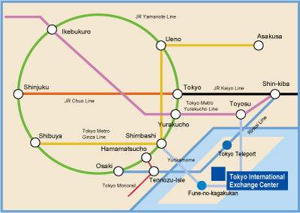
Time: 10:00~17:00

Venue: Plaza Heisei, Tokyo International Exchange Center
(2-2-1 Aomi, Koto-ku, Tokyo, Japan)
Access:
http://www.jasso.go.jp/tiec/map_e.html
●3 minutes from "Fune-no-Kagakukan" station on New Transit "Yurikamome" line
(Shimbashi Station <-> Toyosu Station)
●15 minutes from "Tokyo Teleport" station on "Rinkai" line
(Shinkiba station <-> Osaki station)

If you will be attending, please fill in the information below and return to the secretariat via
fax (+81-82-424-6913) or email (japaneducationforum@yahoo.co.jp) by February 4.

Name:

Affiliation:

Address:

Tel & Fax:

E-mail:

****************************************************************************************
Japan Education Forum Secretariat
Center for the Study of International Cooperation in Education (CICE)
Hiroshima University
1-5-1 Kagamiyama, Higashi-Hirosima, 739-8529, JapanTel: +81-82-424-6959 Fax: +81-82-424-6913
Email: japaneducationforum@yahoo.co.jp
*****************************************************************************************

